Javascript Exercise:

1.**Prompt for amount, interest rate and no. of years and calculate simple interest.**

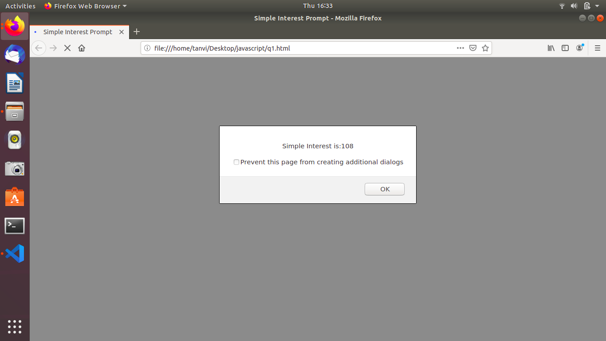

**2.is palindrome string**

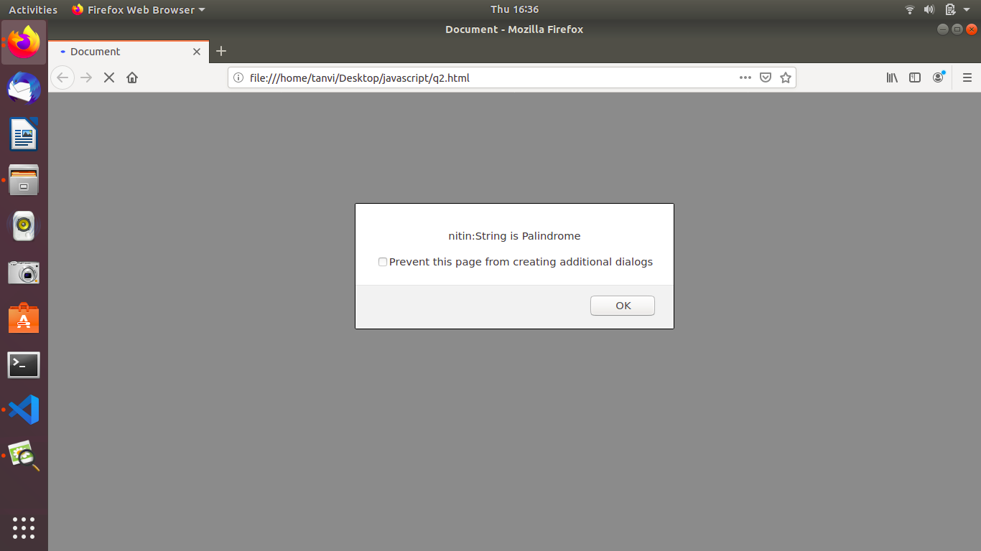

**3.Area of circle**

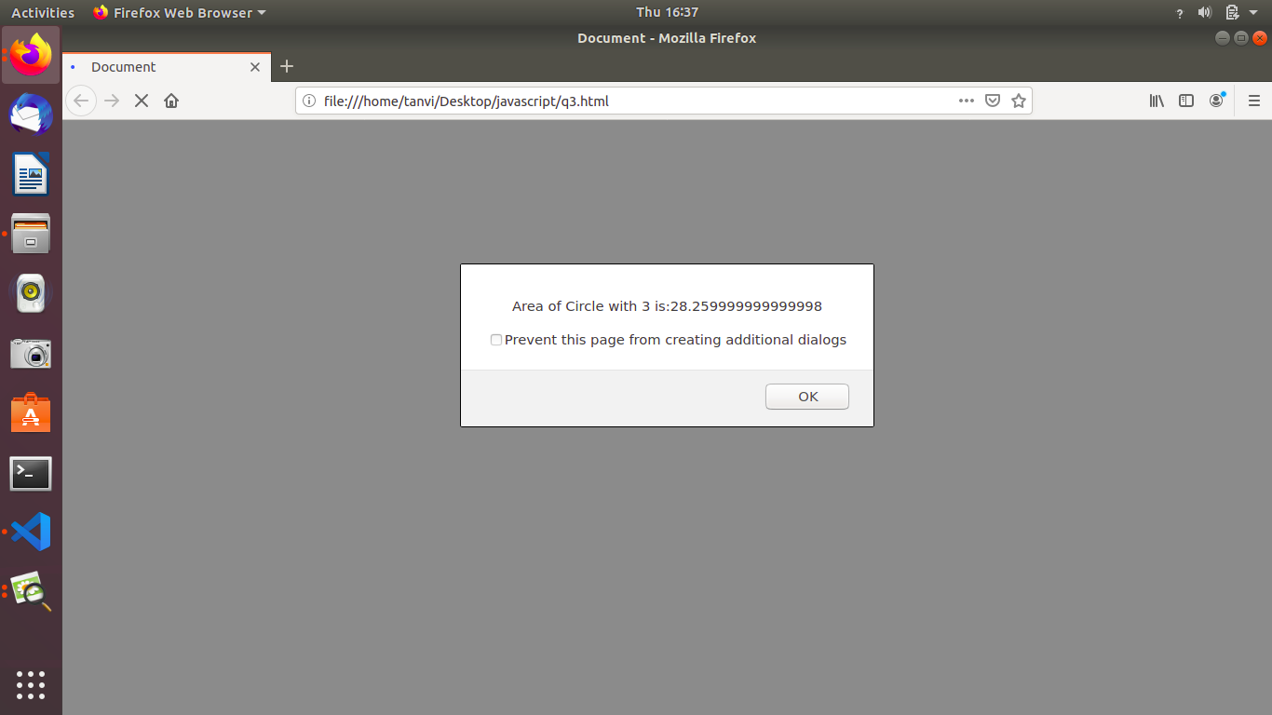

**4.Copy information of one object to another and log it to console.**

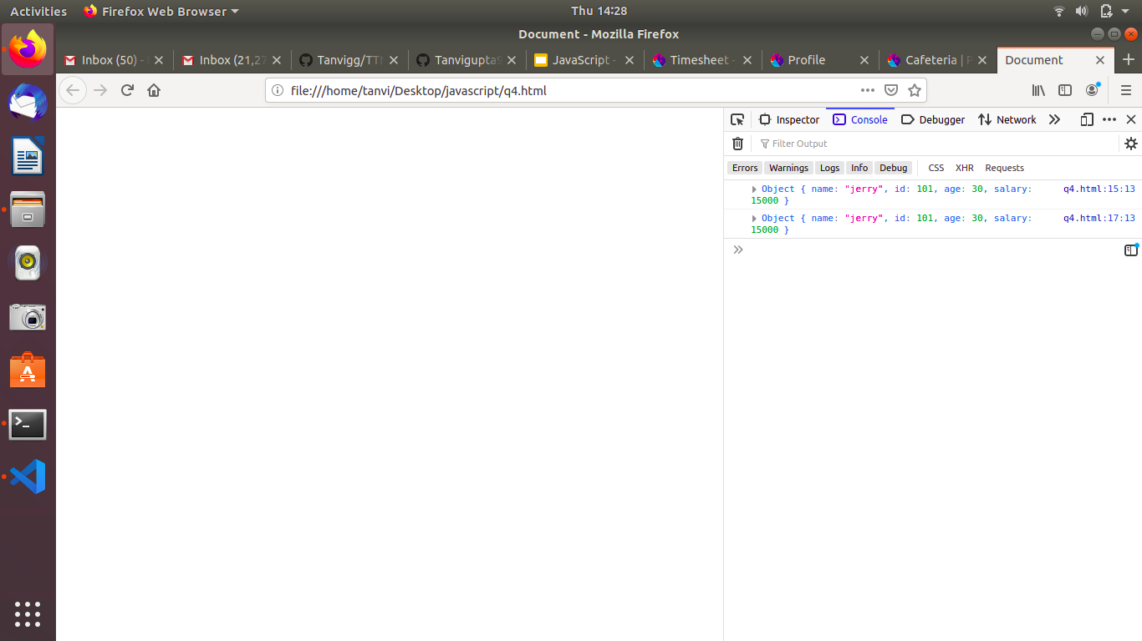

**5.create a list of objects of Employee with info as follow :**

1. **Name, age, salary ,DOB:**

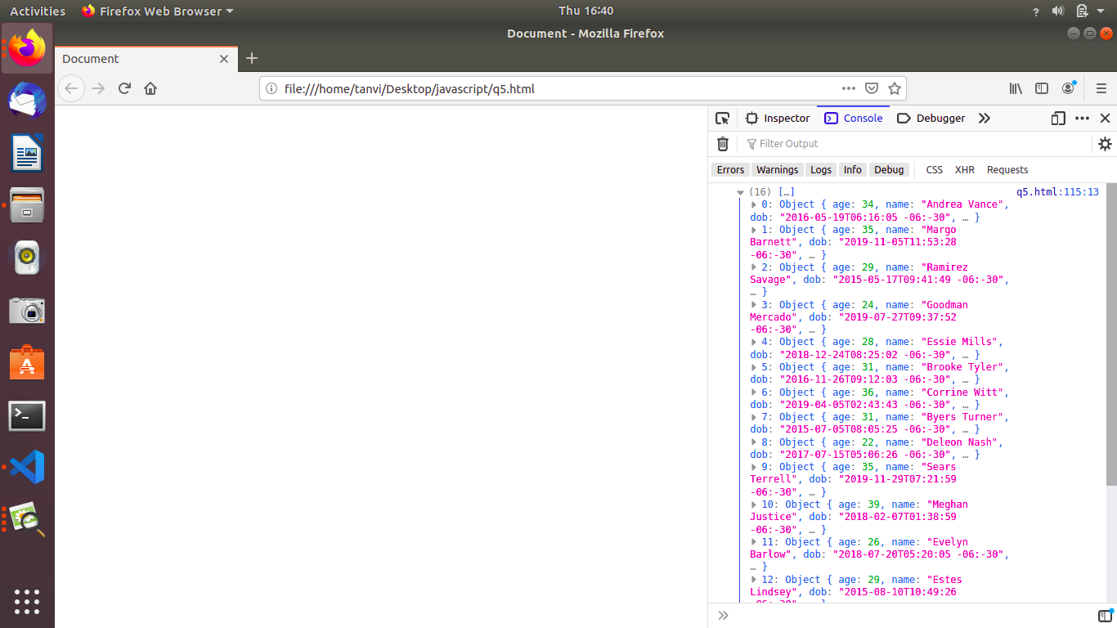

**b.filter all employees with salary greater than 5000.**

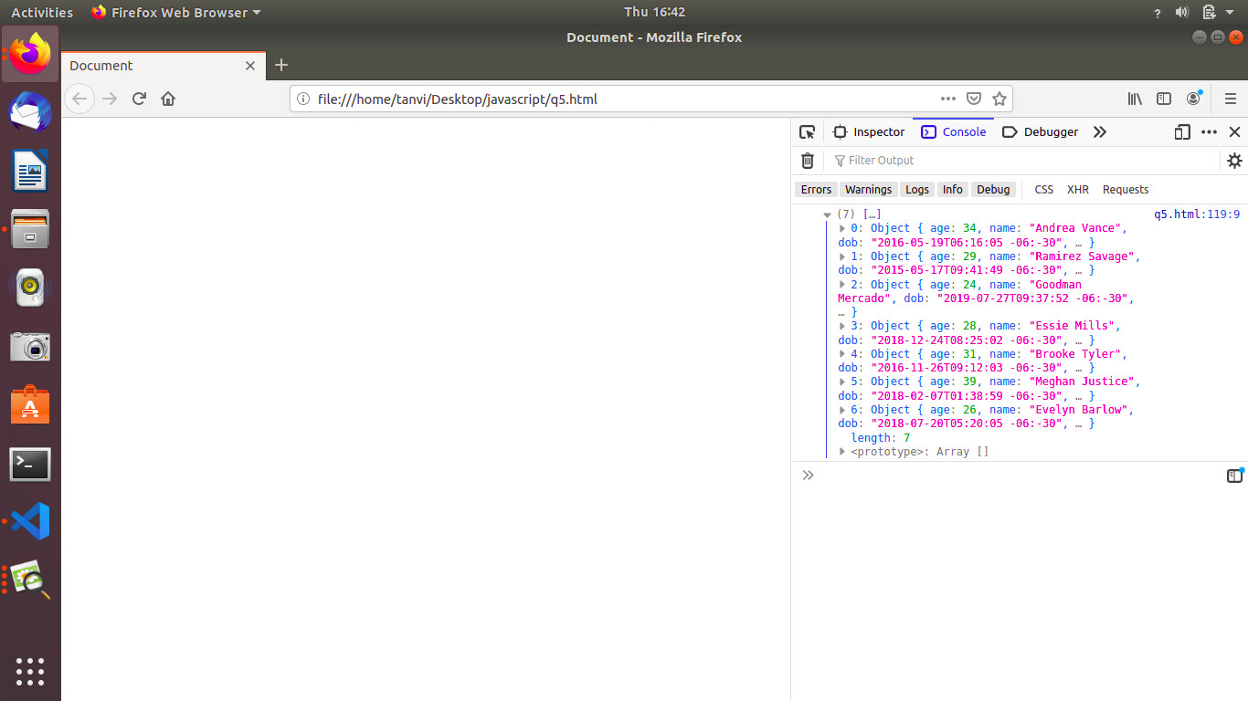

**c.group employee on the basis of their age**

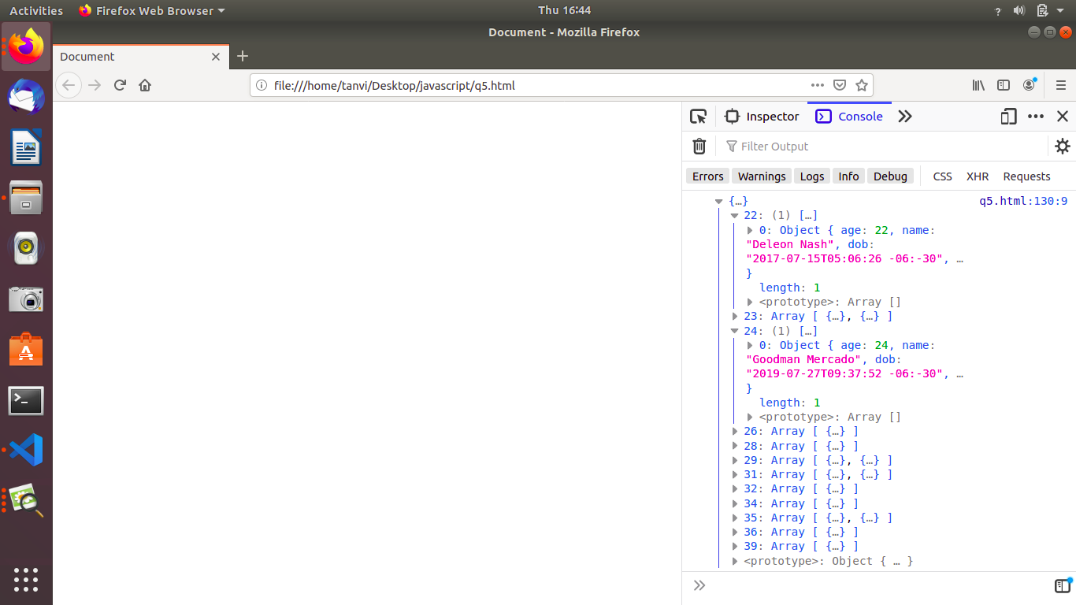

**d.fetch employees with salary less than 1000 and age greater than 20. Then give them an increment 5 times their salary.**

